ELECTRONIC CIRCUITS
MINI PROJECT SYNOPSIS
TOPIC: HOME AUTOMATION


TEAM MEMBERS:

1.MUSKAAN SINHA(ENG18CS0178)
2.LYSETTI LAKSHMI POOJITHA(ENG18CS0150)
3. MANOJ KUMAR S (ENG18CS0159)
4.NAGA NITESH DEVAKI(ENG18CS0181)

CONTENTS:

1. Introduction…………………………………….1
1.1 Motivation…………………………………..2
1.2 Problem statement…………………………..3
2. Software Requirements………………………...4
3. Hardware Requirements………………………..5
4. Circuit Designing……………………………….6
5. Flow Diagram…………………………………..7
6.Conclusion……………………………………….8
7.References………………………………………..9

INTRODUCTION

Home Automation is a term used to describe the working together of all household amenities and appliances. For example, a centrally-controlled LCD panel can have the capability to control everything from heating, air conditioning, security systems, audio systems, video systems, lighting, kitchen appliances, and home theatre installations.

1.1 MOTIVATION:

The household activities are automated by the development of special appliances such as water heaters to reduce the time taken to boil water for bathing and automatic washing machines to reduce manual labour of washing clothes. In developed countries, homes are wired for electrical power, doorbell, TV outlets, and telephones. The different application includes when a person enters the room, the light turns on. In advanced technology, the room can sense the presence of the person and who the person is.

1.2 PROBLEM STATEMENT:
The field of Automation has well advanced in Industries, as majority of automobile industry plants as well as bottling plants have Automated assembly lines. But automation has not yet penetrated in the homes especially in India. If automation was to be used in homes than everyday life would be get eased. Simple example of use of automation in home can be seen in the transfer of water from the under-ground water tank to the over-head water tank, by sensing the level of water in both the tanks. This process eases the every time effort the user has to put in for filling the tank and also helps in saving water. Also people are getting more acquainted daily with the use of Smartphone and tablets which are capable of doing much of PC’s work handy. So we have decided to make a low cost Embedded System in which the smart phones can be used to help automate entire home. In this system the user will have remote access and control over all the subsystems present in the house
2.SOFTWARE REQUIREMENTS

1.MIT APP INVENTOR
2. ARDUINO GENEUINO SOFTWARE

3. HARDWARE REQUIREMENTS

1. ARDUINO UNO BOARD
2. JUMPER WIRES
3. 4 CHANNEL RELAY BOARD(5V)
4.BLUETOOTH HC-05 MODULE
5. LEDS
6. CONNECTING WIRES
7.USB CABLE (D TYPE)
8. CARDBOARDS

4. DESIGN METHODOLIGIES

CIRCUIT EXPLANATION:

The field of Automation has well advanced in Industries, as majority of automobile industry plants as well as bottling plants have Automated assembly lines. But automation has not yet penetrated in the homes especially in India. If automation was to be used in homes than everyday life would be get eased. Simple example of use of automation in home can be seen in the transfer of water from the under-ground water tank to the over-head water tank, by sensing the level of water in both the tanks. This process eases the every time effort the user has to put in for filling the tank and also helps in saving water. Also people are getting more acquainted daily with the use of Smartphone and tablets which are capable of doing much of PC’s work handy. So we have decided to make a low cost Embedded System in which the smart phones can be used to help automate entire home. In this system the user will have remote access and control over all the subsystems present in the house.

5.CIRCUIT DESIGNING
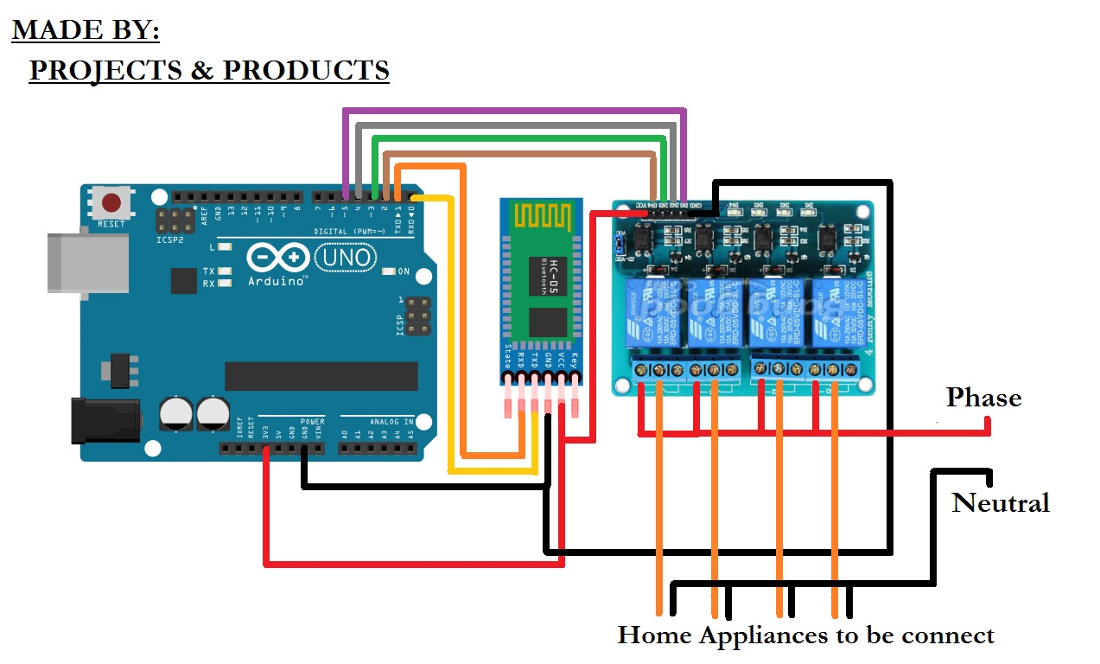

6.FLOW DIAGRAM
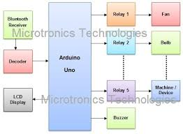

7.CONCLUSION

As we realize the benefits of home automation system, the demand for these stuff increases. These devices are being produced by different manufacturers to work in conjunction with home automation. Based on the research, the various kinds of applications are as follows:
- Outdoor watering systems – Home owners have opted for home automation systems to water plants instead of using a hose to water them. With the help of the home automation system, the presence of the home owner is not essential. Latest developments have manufactured home automation systems where the home owners do not have to push a button or flip a switch to carry out the task.
- Pools and spas – Certain pools are automated to fill the poll with water when a person enters. This automation is possible only if the plumbing source is connected to the solenoid valve and moisture sensor. The homeowner needs to install switches in order to turn on/off these devices by using a home automation system. Spa controls have their own controls and control panels which makes it different from the pool controls.
- Anti-icing – The tool of anti-icing is being utilized for gutters, sidewalks, driveways, and roofs. The two technologies used with anti-icing system are electrical and hydronic.

8. REFERENCES

1. INTERNET
2. EDGEFLEX WEBSITE
3. ENGINEERING GARAGE WEBSITE
4. YOUTUBE

